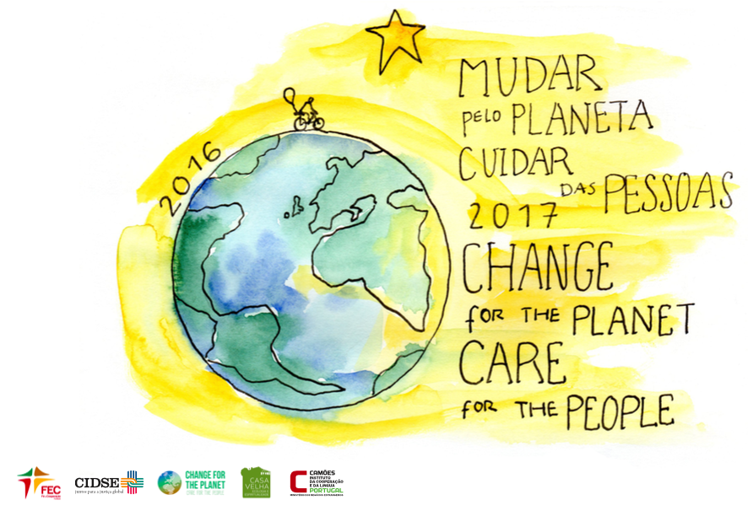

SUSTAINABLE CAMP SCHEDULE LAUDATO SI’ IN ACTION
Portugal, MAY 9 - 13 2017

Venue: Casa Velha

DAY | THEME | MORNING | AFTERNOON | EVENING
9 | TOWARDS A NEW LIFESTYLE |  | 17:00 - Welcome to Casa Velha  18:00 - Knowing the Camp and the Community | 19:00 - Dinner  21:00 - Camp Program Presentation  23:00 - Good night!
10 | EDUCATING FOR THE COVENANT BETWEEN HUMANITY AND THE ENVIRONMENT | 8:00 - Mass (optional)  8:30 - Breakfast  9:00 - Launch of the day with a spiritual moment  9:30 - Time to Take Care of Our Common Home (practical work in the farm)  12:30 - Lunch | 14:30 - How do we Change? Round table and marketplace with experiences from different countries.  17:30 - Mini groups Sharing | 19:00 - Dinner  21:00 - Storytelling Movie and discussion with the filmmaker Patrícia Pedrosa and some other guests  23:00 - Thank the day  23:30 - Good night!
11 | ECOLOGICAL CONVERSION | 8:00 - Mass (optional)  8:30 - Breakfast  9:00 - Launch of the day  9:30 - Time to Take Care of Our Common Home (practical work in the farm)  12:30 - Lunch | 14:30 – Workshop on “our own Paris Agreement”  17:30 - Mini groups Sharing | 19:00 - Party with the Vale Travesso village  23:00 - Thank the day  23:30 - Good night!
12 | JOY AND PEACE | 8:30 - Breakfast  9:00 - Launch of the pilgrimage and shipping prayer  10:30 - International (Walk) for Change | 16:00 - Arrival to Fátima | 21:00 - Vigil with Pope Francis  22:00 - Mass  Camping night at Fátima
13 | QUEEN OF ALL CREATION | 10:00 - Mass with Pope Francis | 13:00 - Bus to Lisboa

